Day 3: DNS Server Configuration Theory
Q1. Install and set up a DNS server on your local machine or a VM using BIND (Linux) or Simple DNS Plus (Windows), then create a new DNS zone for the domain
musicmania.in.
Ans:
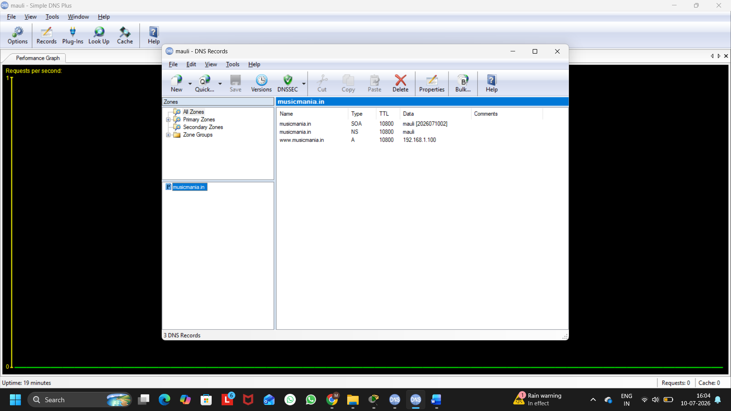
Figure 1: DNS Zone (musicmania.in) with A Record Configuration in Simple DNS Plus

Explanation:
A new DNS Primary Zone named musicmania.in was created in Simple DNS Plus. An A Record (www.musicmania.in) was added and mapped to the IP address 192.168.1.100. This allows the DNS server to resolve the domain name to its corresponding IP address.
Q2. Add an A record in your DNS server configuration to map www.musicmania.in to the IP address 192.168.1.50, then use the nslookup or dig command to verify the mapping works.
Ans:
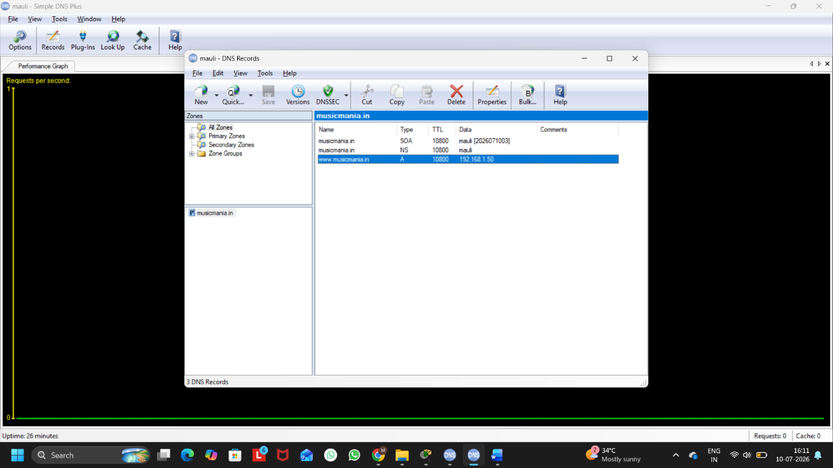
Figure 1: A Record Mapping www.musicmania.in to 192.168.1.50
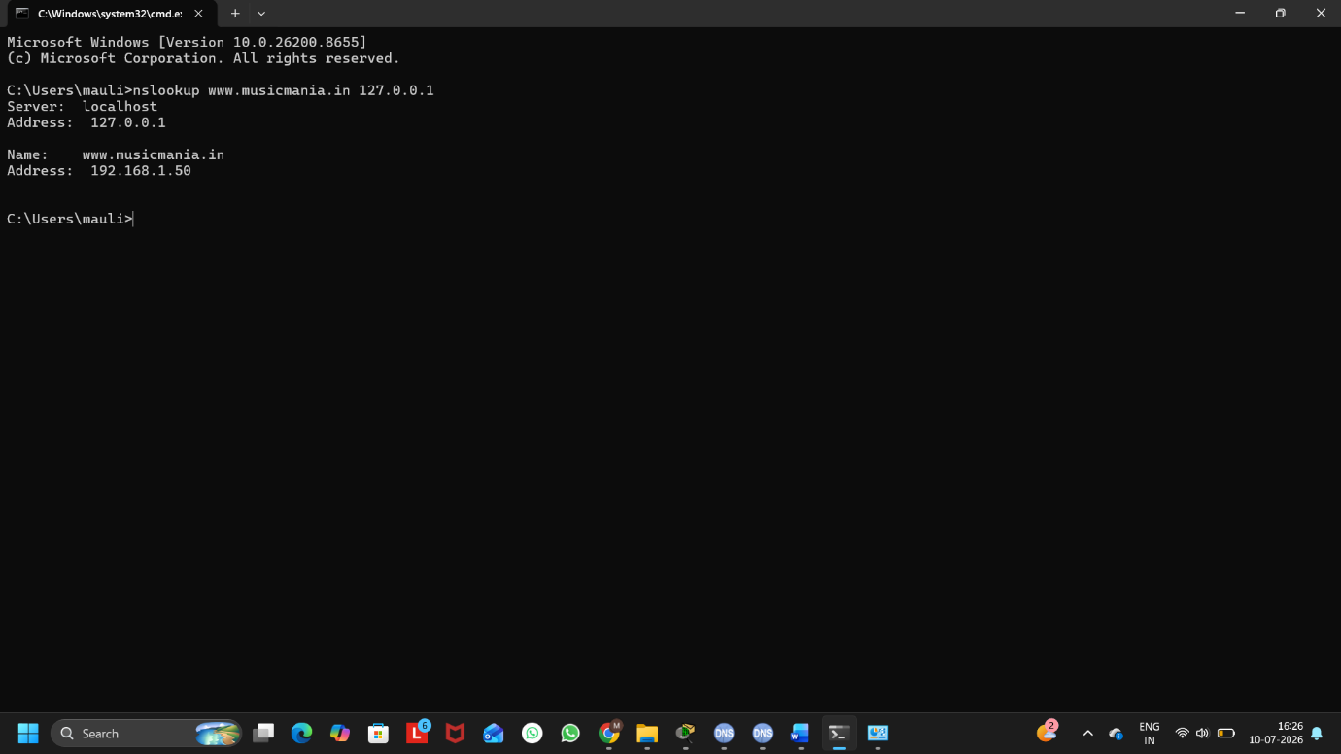
Figure 2: NSLookup Verification of www.musicmania.in
Verification:
The A record was created to map www.musicmania.in to the IP address 192.168.1.50. The nslookup command successfully resolved the domain name to the configured IP address, confirming that the DNS server is working correctly.
Q3. Simulate a typo by adding a CNAME record for play.musicmania.in that points to www.musicmania.in, then test if accessing play.musicmania.in resolves to the correct IP address.
Ans:
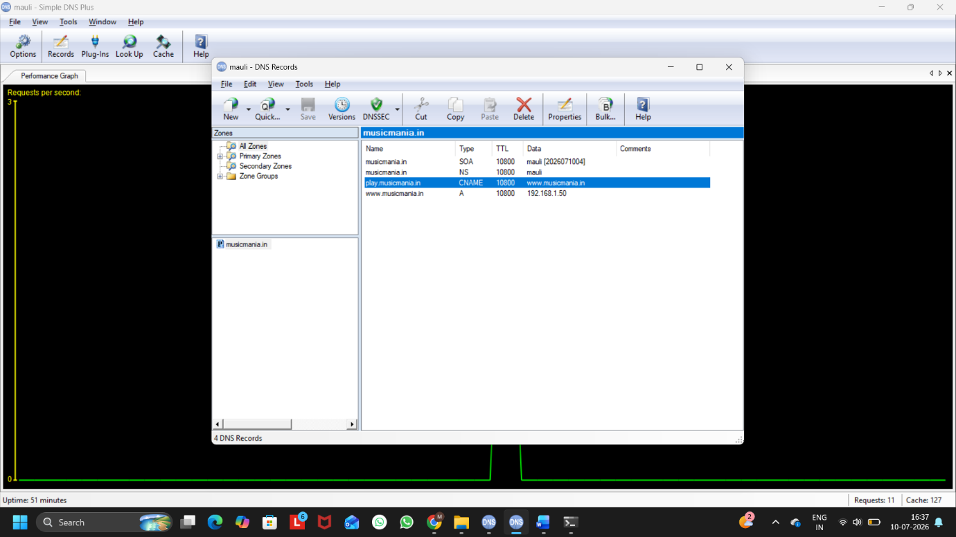
Figure 1: CNAME Record for play.musicmania.in

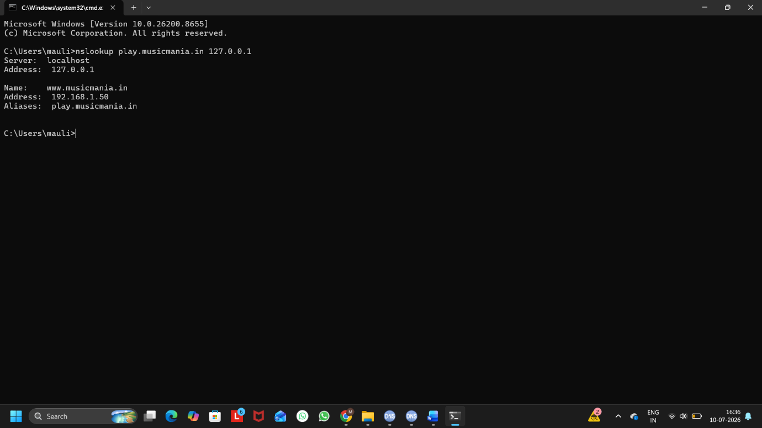
Figure 2: NSLookup Verification of play.musicmania.in
Explaination:
The CNAME record maps play.musicmania.in to www.musicmania.in instead of directly storing an IP address. When nslookup is executed, the DNS server first resolves the alias to www.musicmania.in and then returns the IP address 192.168.1.50.

Q4. Your DNS server is not resolving the domain musicmania.in as expected. Document the step-by-step troubleshooting process you would follow, including checking configuration files, restarting the DNS service, and testing with nslookup or dig.<br><br><em><strong>Hint:</strong> Include at least three different troubleshooting commands or checks in your documentation.</em>
Ans:
Step-by-Step Troubleshooting:
Step 1: Check DNS Zone Configuration
- Open Simple DNS Plus.
- Verify that the musicmania.in zone exists.
- Check that the A Record for www.musicmania.in points to the correct IP address (192.168.1.50).
- Ensure there are no spelling mistakes in the domain name.

Step 2: Verify DNS Records
- Confirm that all required DNS records (SOA, NS, A, or CNAME) are present.
- Save any recent changes made to the DNS configuration.

Step 3: Restart the DNS Service
- Open Simple DNS Plus.
- Restart the DNS service to apply configuration changes.
- Wait a few seconds for the service to start again.

Step 4: Test Using nslookup

Open Command Prompt and run:
nslookup www.musicmania.in 127.0.0.1
Expected Result:
Name: www.musicmania.in
Address: 192.168.1.50

Step 5: Test Another Record
- If a CNAME record exists, verify it using:
- nslookup play.musicmania.in 127.0.0.1
- This confirms that the alias correctly resolves to the configured IP address.

Step 6: Check DNS Service Status
Ensure that:
- The DNS service is running.
- The firewall is not blocking DNS requests.
- Port 53 is available.

Commands / Checks Used:
nslookup www.musicmania.in 127.0.0.1
nslookup play.musicmania.in 127.0.0.1
ipconfig /flushdns

